# RF Communication Motion System

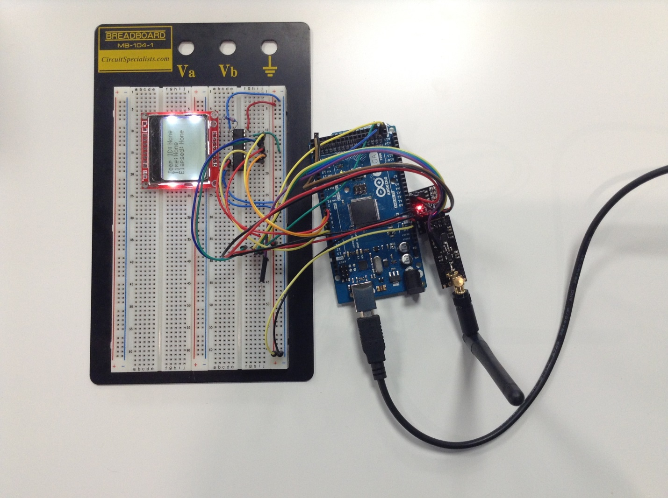

5

4

1

3

2

## Main Components/Boards

|  |  |
| --- | --- |
|  | [Arduino Mega R3](https://www.arduino.cc/en/Main/ArduinoBoardMega2560) |
|  | [Arduino Uno](https://www.arduino.cc/en/Main/ArduinoBoardUno) (For V1.1) |
|  | [2.4G wireless module NRF24L01+PA+LNA (PA-IPX)](.4G%20wireless%20module%20NRF24L01+PA+LNA%20(PA-IPX)) |
|  | [Base Module for nRF24L01 - 3.3V Regulator](http://yourduino.com/sunshop/index.php?l=product_detail&p=467) |
|  | [SN74LVC245A Octal Bus Transceiver With 3-State Outputs](http://www.digikey.com/product-detail/en/texas-instruments/SN74LVC245AN/296-8503-5-ND/377483) |
|  | [Graphic LCD 84x48 - Nokia 5110](https://www.sparkfun.com/products/10168) |

## Software Required

|  |  |
| --- | --- |
|  | [Arduino IDE (latest)](https://www.arduino.cc/en/Main/Software) |

You can find more information including the **libraries** and **tutorials** by clicking on the links above.

## Module-level Functions

### Arduino Mega R3/Arduino Uno

This is the development board. It’s the main board interfacing with all other components/boards. I think of it as the “brain” of the system. Once all the setup work such as assembly, wiring, library installations, programming Arduino is done, Arduino and other components/boards can start communicating with each other.

### 2.4G Wireless Module NRF24L01+PA+LNA (PA-IPX)

This 2.4GHz wireless module supports two roles. The first role is ping out role which is used to transmit data packets (bytes) to its RF peer. The second role is pong back role which is used to receive data packet from its RF peer. For this project, it’s used to transmit/receive the id numbers of its peers.

### Base Module For NRF24L01 - 3.3V Regulator

This is a voltage regulator for the NRF24L01+ module. It also amplifies the current from the Arduino (the current source of the pins is too low, approx. 20mA) so the module can operate at the appropriate power level.

### SN74LVC245A Octal Bus Transceiver With 3-State Outputs

This chip converts 5V input voltage to max. 3.3V output voltage. It’s used to run the LCD screen at 3V from Arduino 5V pins.

### Graphic LCD 84x48 - Nokia 5110

This is the LCD screen used to display the data such as the id number, current timestamp and time elapsed to receive the acknowledge signal of its peer.